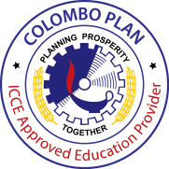
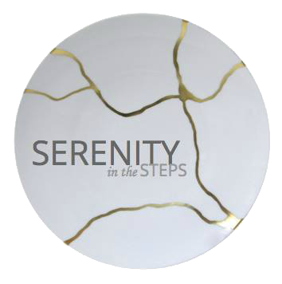

Gentler Solutions to Addiction since 1993

Program Detail for the
Serenity Internship, Training with CP- ICCE ( Colombo plan International Centre for Credentialing and Education of Addiction Professionals )

This is a 6 month course that includes a hands on approach to a 12 step, CBT, Humanist and other evidenced based techniques in a treatment environment plus five of the training tracks of the Universal Treatment Curriculum of Colombo Plan ICCE with ICCE credentialing exams as follows:

Physiology and Pharmacology for Addiction Professionals | 24 hours
Curriculum 2 | Treatment for Substance Use Disorders- The Continuum of Care for Addiction Professionals | 40 hours
Curriculum 3 | Common Co-Occurring Mental and Medical Disorders- An overview for Addiction Professionals | 24 hours
Curriculum 4 | Basic Counselling Skills for Addiction Professionals | 40 hours
Curriculum 4A | Psycho-education for Clients and Families | 30 hours
Curriculum 5 | Assessment and Intake, Treatment Planning, and Documentation for Addiction Professionals | 30 hours
Curriculum 6 | Case Management for Addiction Professionals | 16 hours
Curriculum 7 | Crisis Intervention for Addiction Professionals | 16 hours
Curriculum 8 | Ethics for Addiction Professionals | 32 hours
Recovery Coach | Developing Community Support Systems | 30 hours

Other inclusions:
- Clinical Supervision
- Contact Hours
- Meals and bed during duty hours
- ICCE board exams ( as available)

Requirements:

- Step 5 completed if in recovery and active with sponsor
- 6 months clean and sober time
- Internship fee P 125,000
- ICCE training and Exam fees $ 1950.00 ( hotels and plane fares excluded)

Accommodations:

Dorm type lodgings ( 3-6 peeps/ room) Are available at Serenity or at our halfway hotel ,Villa Silvina on Outlook drive at
P 6000/ month or Twin sharing at P 20,000 and single occupancy at P 35,000/ month (matrimonial bed)

Payments :
Cash or deposit to BDO as per instructions.

Financing also available thru Citibank http://www.citibank.comph/gcbloans/loans.htm
Care of Jocelyn.vasquez.liberato@citi.com CP 0915 396 9702

ENROLLMENT:

I ______________________________ after being fully apprised of the above Program hereby enrol myself and abide by the rules of Serenity in the Steps for this program. Enclosed is my payment of Pp/$ ________________________.
Serenity Reserves the right to unilaterally terminate this engagement should we find the Addiction Professional Candidate
Lacking and / or in violation of professional ICCE ethical standards

______________________ ____________________
ICAP / RC Candidate Serenity In the Steps
Print name and signature

